Salesforce Dashboards

Table of Contents

Notes: 1

Money Movement Overview Dashboard 2

Standard Process/ Account Opening or Funding Dashboard 2

RMS and Gifting Dashboards 3

RMD Transactions Dashboard 3

Roth Conversions Dashboard 4

Charitable Gifting Dashboard 5

Retirement Account Funding Dashboard 5

Beneficiary Update 6

Financial Plan 7

Model Assignment 7

Client Meetings 8

Registration Change 9

IAA Update 9

High Net Worth 10

Transfer of Account 11

# Notes:

1. More reports could be suggested based on the actual data for analysis.
2. The following dashboards consist of basic reports dependent on the fields relevant to the records and relationships.
3. All Reports and Dashboards are public, in case any report/ dashboard does not open, check for access and have the folder changed to Public.

# Money Movement Overview Dashboard

Link: <https://epwa--dev.sandbox.lightning.force.com/lightning/r/Dashboard/01Zdi0000000b7dEAA/view?queryScope=userFolders>

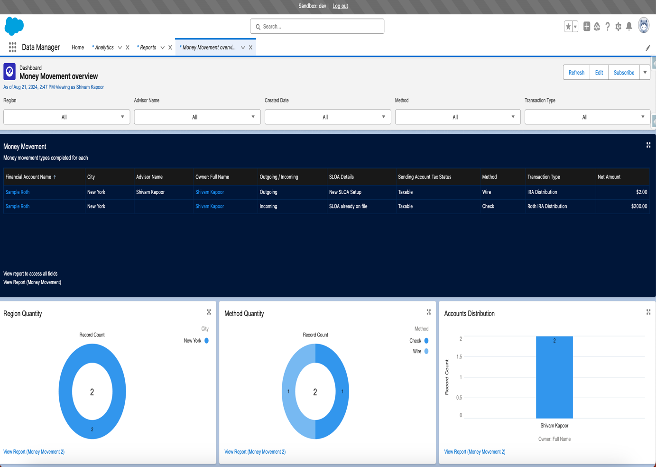

# Standard Process/ Account Opening or Funding Dashboard

Link: <https://epwa--dev.sandbox.lightning.force.com/lightning/r/Dashboard/01Zdi0000000bFhEAI/view?queryScope=userFolders>

# RMS and Gifting Dashboards

## RMD Transactions Dashboard

Link: <https://epwa--dev.sandbox.lightning.force.com/lightning/r/Dashboard/01Zdi0000000b9FEAQ/view?queryScope=userFolders>

## Roth Conversions Dashboard

Link: <https://epwa--dev.sandbox.lightning.force.com/lightning/r/Dashboard/01Zdi0000000bArEAI/view?queryScope=userFolders>

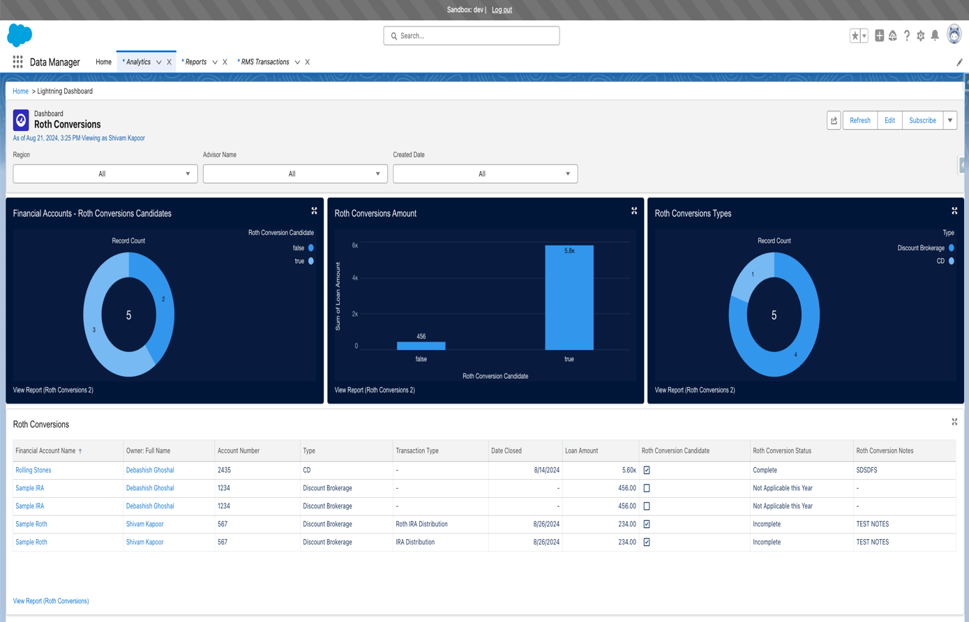

## Charitable Gifting Dashboard

Link: <https://epwa--dev.sandbox.lightning.force.com/lightning/r/Dashboard/01Zdi0000000bCTEAY/view?queryScope=userFolders>

## Retirement Account Funding Dashboard

Link: <https://epwa--dev.sandbox.lightning.force.com/lightning/r/Dashboard/01Zdi0000000bE5EAI/view?queryScope=userFolders>

# Beneficiary Update standard process dashboard

Link: https://epwa--dev.sandbox.lightning.force.com/lightning/r/Dashboard/01Zdi0000000bHJEAY/view?queryScope=userFolders

# Financial Plan

Link: <https://epwa--dev.sandbox.lightning.force.com/lightning/r/Dashboard/01Zdi0000000bKXEAY/view?queryScope=userFolders>

# Model Assignment

Link: https://epwa--dev.sandbox.lightning.force.com/lightning/r/Dashboard/01Zdi0000000bM9EAI/view?queryScope=userFolders

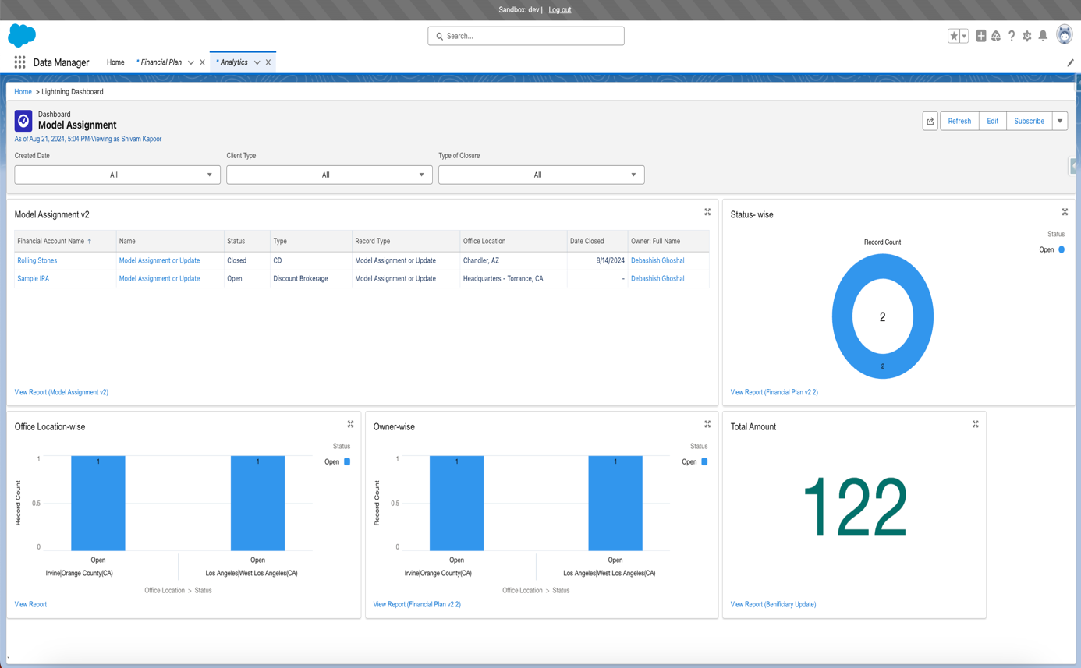

# Client Meetings

Link: https://epwa--dev.sandbox.lightning.force.com/lightning/r/Dashboard/01Zdi0000000bNlEAI/view?queryScope=userFolders

# Registration Change

Note: The amounts are sample reports on different record types (because of insufficient data in the developer org) and would be based on the record type with actual data.

Link: https://epwa--dev.sandbox.lightning.force.com/lightning/r/Dashboard/01Zdi0000000bIvEAI/view?queryScope=userFolders

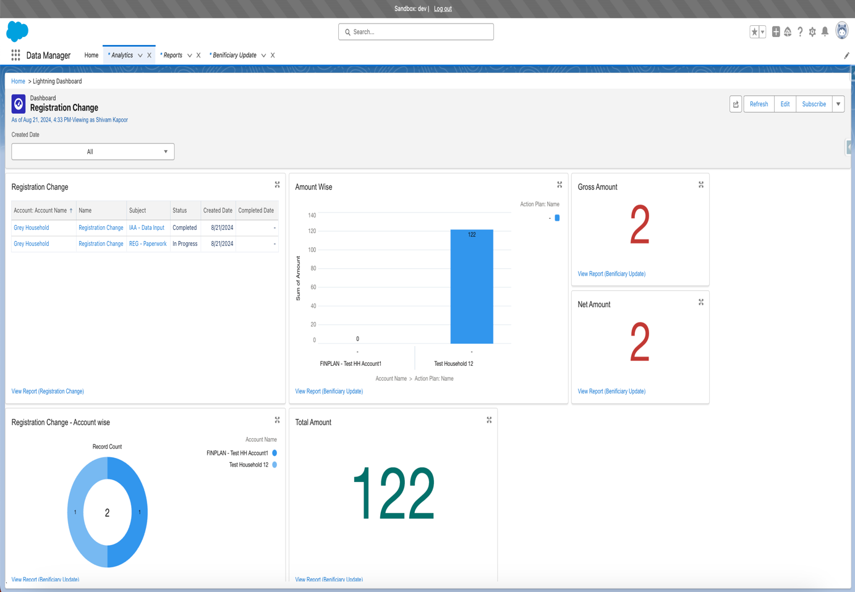

# IAA Update

Link: https://epwa--dev.sandbox.lightning.force.com/lightning/r/Dashboard/01Zdi0000000bPNEAY/view?queryScope=userFolders

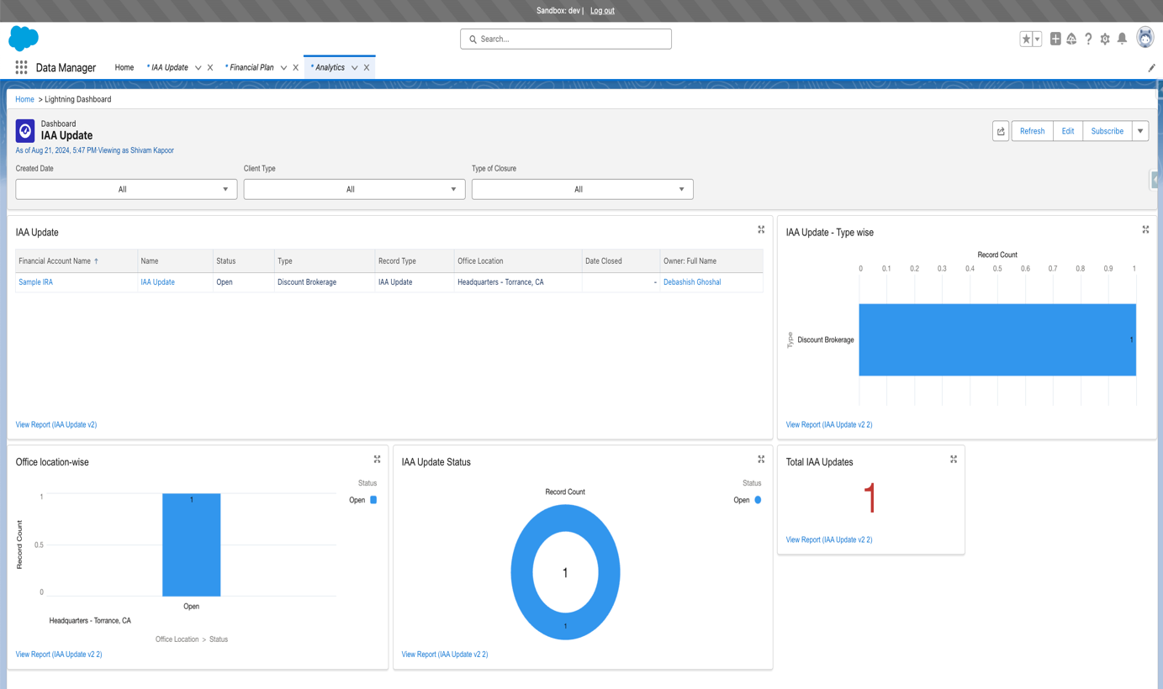

# High Net Worth

Link: https://epwa--dev.sandbox.lightning.force.com/lightning/r/Dashboard/01Zdi0000000bQzEAI/view?queryScope=userFolders

# Transfer of Account

Link: https://epwa--dev.sandbox.lightning.force.com/lightning/r/Dashboard/01Zdi0000000blxEAA/view?queryScope=userFolders

